"a spectacular mastery of phrasing and harmony”
- Jazz Magazine (FR)

"an incredible saxophonist, with something very unique and original to say”
- Walter Smith III
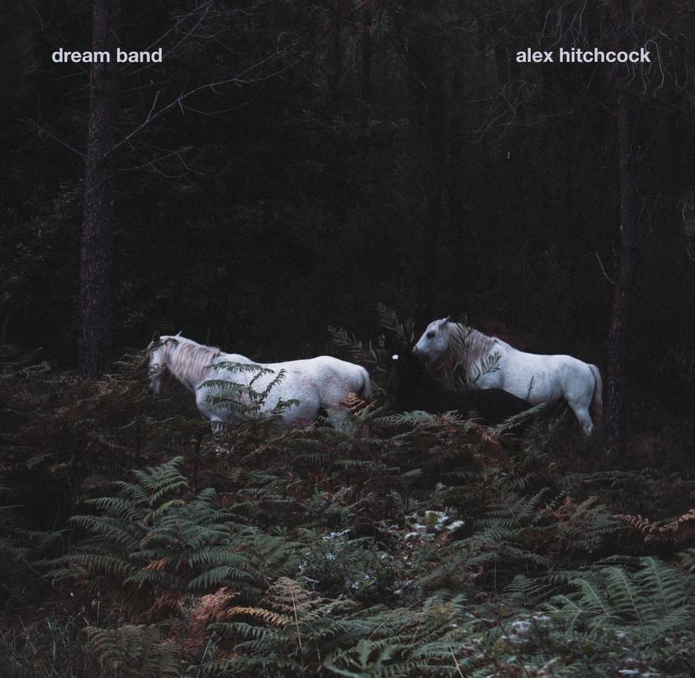
It’s a question that has absorbed bandleaders for many years: who are the perfect musicians to bring my music to life? As his upcoming album Dream Band suggests, virtuoso London saxophonist Alex Hitchcock has plenty of thoughts on the matter...

In his second release with legendary Barcelona label Fresh Sound New Talent, the Ivor Novello-nominated composer pulls together a pool of 15 musicians from both sides of the Atlantic to bring to life a set of forward-thinking music.

New York heavy-hitters Chris Cheek (Bill Frisell, Charlie Haden), Jason Brown (Kurt Rosenwinkel, Monty Alexander) and David Adewumi (Dave Douglas) line up alongside a who’s who of the burgeoning London jazz scene, including Jazz FM vocalist of the year Cherise Adams Burnett, BBC Young Jazz Musician of the Year Deschanel Gordon and multi-genre cellist/vocalist Midori Jaeger.

The music was recorded across three consecutive days in a London studio in May 2021, with a different configuration of musicians each day. The result is a selection of 12 original songs ranging from a delicate duo (featuring the sensational Midori Jaeger on cello & vocals) through to an expansive 7-piece outing with guest stars Chris Cheek and David Adewumi.

But whilst managing such a large and varied group of musicians for one album might sound like a challenge in itself, Hitchcock shows his pedigree both as a bandleader and arranger in turning a colourful yet finely-tuned set of songs into a coherent whole.

All About Jazz noted “the stratospheric trajectory” of Hitchcock’s group back in 2018, Jazzwise named him as “one to watch” in 2019, whilst his 2020 release on Edition Records was hailed as “a direct hit” by German magazine Jazzthing.

Now, as 2021 draws to a close, Dream Band and Fresh Sound New Talent present Hitchcock’s most compelling case to date as to why he and his carefully-curated groups are finding themselves more and more in demand at clubs and festivals on the international jazz scene.

Streaming: Soundcloud Photos/packshot: download WAVs: download
Videos: Wolf and Nina | to love itself | Simulacra
More info: alexhitchcock.co.uk | Press requests: alex@alexhitchcock.co.uk
Alex writes:

I wanted to make a project that could only happen at this specific moment in time, bringing together different musicians I’ve connected with over my time in London. The pandemic offered an opportunity, both to get the musicians together practically but also to respond positively (and with unity) to the difficult past year. I wanted to create space for these musicians to express themselves and shape my music – some of whom I’ve worked with for 10 years, and some of whom are new to me.

I felt lucky to be surrounded by so many distinctive and contrasting voices, wanted to capture that variety in an album rather than just recording one band. At a time when people weren’t able to play and create as much I wanted to go the other way, taking a maximalist approach to make something that was ambitious and wide ranging.

Partly, it was a kind of ‘curating’ – I wanted to bring these combinations of musicians together and allow them to make the music their own – every single musician made creative decisions over the three days’ recording that changed the direction of the tune as I’d originally conceived it.

The title, ‘Dream Band’ – I imagined what different combinations of my favourite musicians would sound like and wrote music for that. But it’s not something that’s totally fixed, with the lineups changing throughout the album. There are multiple possible dream bands…

Some brief track notes…

Wolf and Nina: I wrote this about the reassurance of having non-human companions in situations of stress. In this case - my cats in the pandemic; their blissful ignorance to turmoil in the human world, and their lack of change in behaviour being a comfort. Midori Jaeger wrote the lyrics, with themes of enmeshment/entanglement and the strains of isolation on various relationships.

Yeshaya: I watched my friend get married on Zoom just before soundchecking for one of my first gigs back this summer, at Pizza Express for my friend Joe Downard (who’s on the album) who had just had a baby, launching his own album. The whole thing contributed to an intense emotional experience, valuing the connections I had with those people; the contrast reminded me of the power of making music in the same place, with the wedding was far away but the gig being in person.

to love itself: The title is from ‘We are the/Universe learning to love itself’, a lyric from an Ambrose Akinmusire song. I got to work with some of my closest friends and musical collaborators on this album - I wanted to capture that closeness by having a circular song, where everyone solos successively as the song builds.

Embers: One of my heroes is Joshua Redman and his trio records are some of my favourites. I thought having the great drummer Jason Brown in the studio was too good an opportunity to miss to play some trio as a kind of tribute

Overcome Any Obstacle with a Horse: this was written on a spectator’s placard at the Tokyo Olympics this year

Track Listing

- Wolf and Nina (feat. midori jaeger)
- Yeshaya
- intro
- to love itself
- outro
- FSTL (feat. Chris Cheek, David Adewumi)
- Move 37
- Azalea (feat. midori jaeger)
- Embers
- Overcome Any Obstacle With A Horse
- Simulacra
- And Then

Personnel

ALEX HITCHCOCK saxophone
CHERISE ADAMS-BURNETT voice (Tracks 4, 6)
CHRIS CHEEK saxophone (Track 6)
DAVID ADEWUMI trumpet (Track 6)
DESCHANEL GORDON piano (Tracks 1, 10)
FERG IRELAND bass (Tracks 2, 7, 9, 11)
JAS KAYSER drums (Tracks 1, 10)
JASON BROWN drums (Tracks 2, 7, 9, 11)
JOE DOWNARD bass (Tracks 3, 4, 5, 6, 12)
LUISITO QUINTERO percussion (Track 7)
MIDORI JAEGER voice/cello (Tracks 1, 8, 10)
NOAH STONEMAN piano (Tracks 2, 7, 11)
SHANE FORBES drums (Tracks 3, 4, 5, 6, 12)
WILL BARRY piano (Tracks 3, 4, 5, 6, 12)
WILL SACH bass (Tracks 1, 10)

SONNY JOHNS recording & mixing engineer
JORDI PUJOL executive producer
All tracks written by Alex Hitchcock apart from Azalea by Duke Ellington. Lyrics to Wolf and Nina by Midori Jaeger.
Recorded at Fish Factory, London for Fresh Sound New Talent, 10-12th May 2021

